* **Name of the Activity:** A seminar on " State Level Seminar on "Theatre and Dramaturgy in Sanskrit'' and book launch event of "Humanism in Indian Education"”
* **Type of the Activity:** Seminar
* **Organizing Department**: Department of Sanskrit, Chakdaha College
* **Date and time of the Activity**: 23-02-2022
* **Number of participants:** 92
* **Information regarding Seminar:**

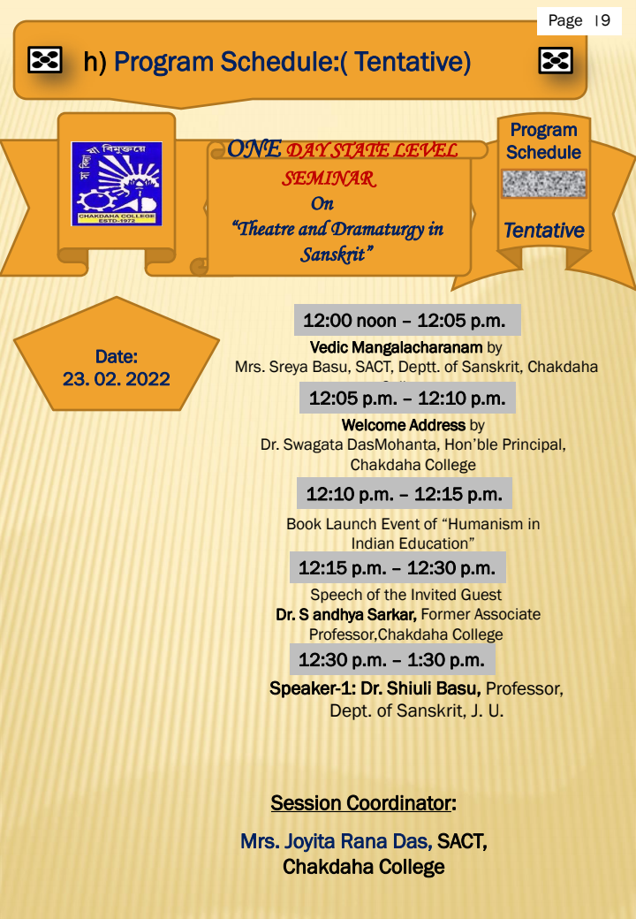

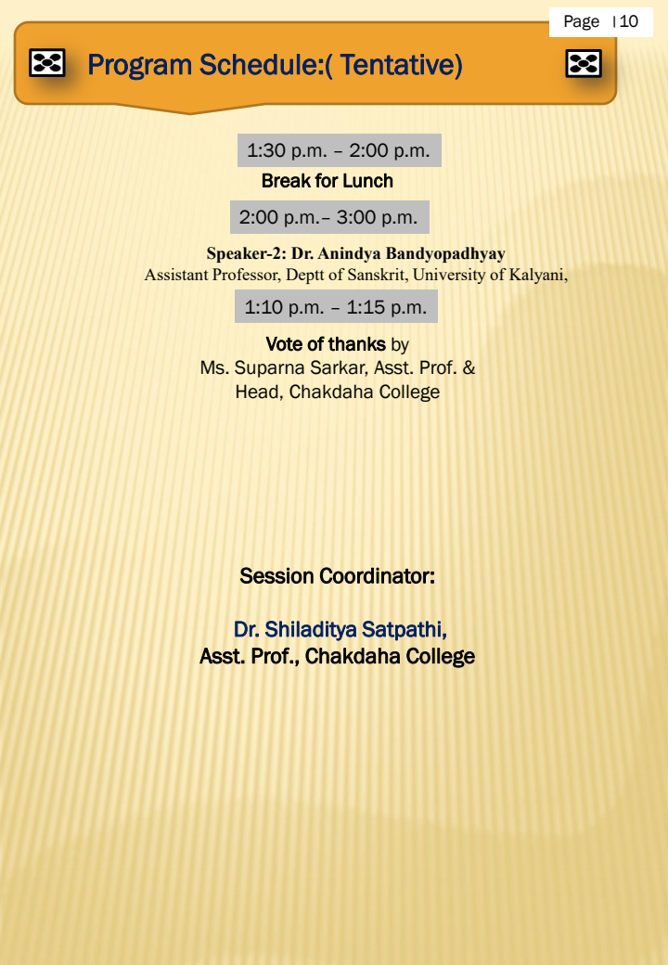

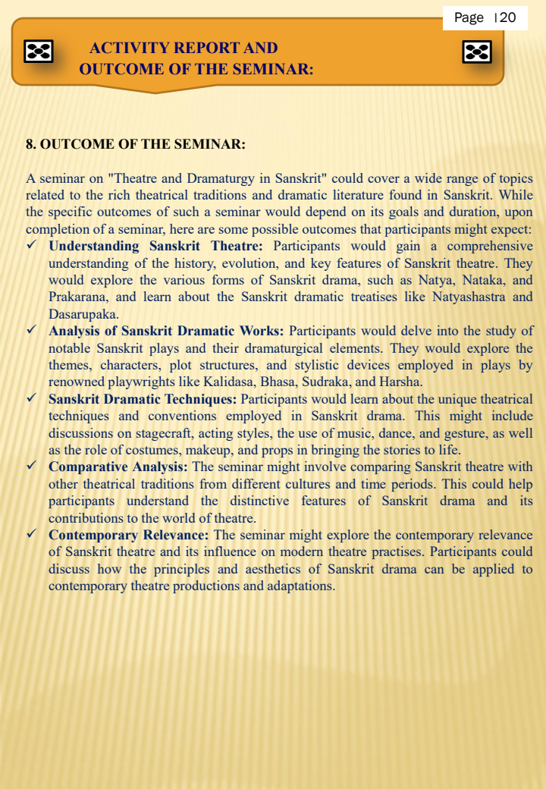

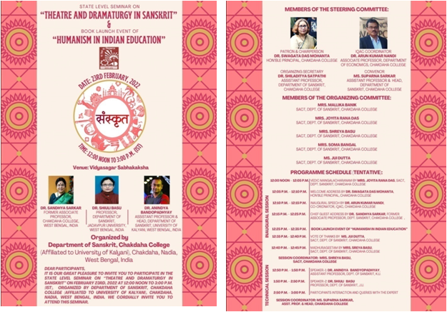

* **Photographs of the Programme:**

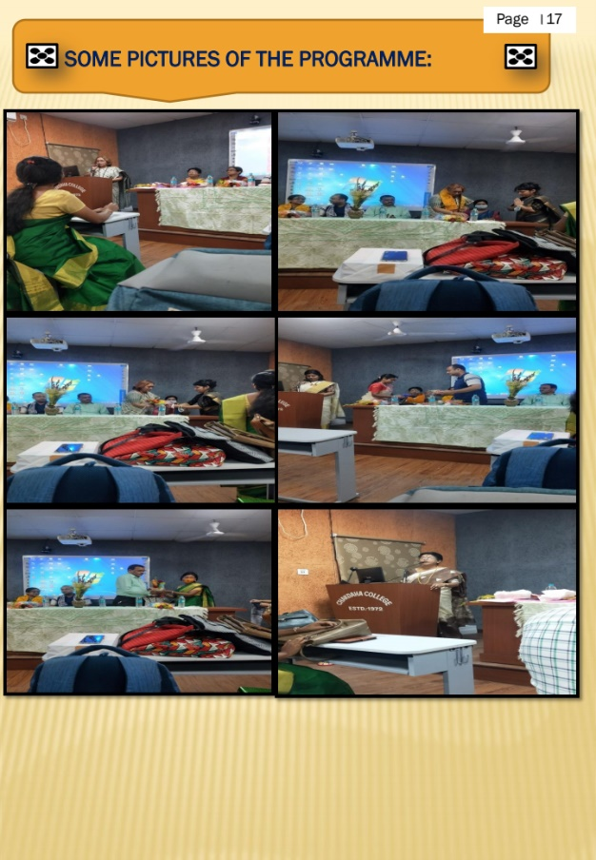

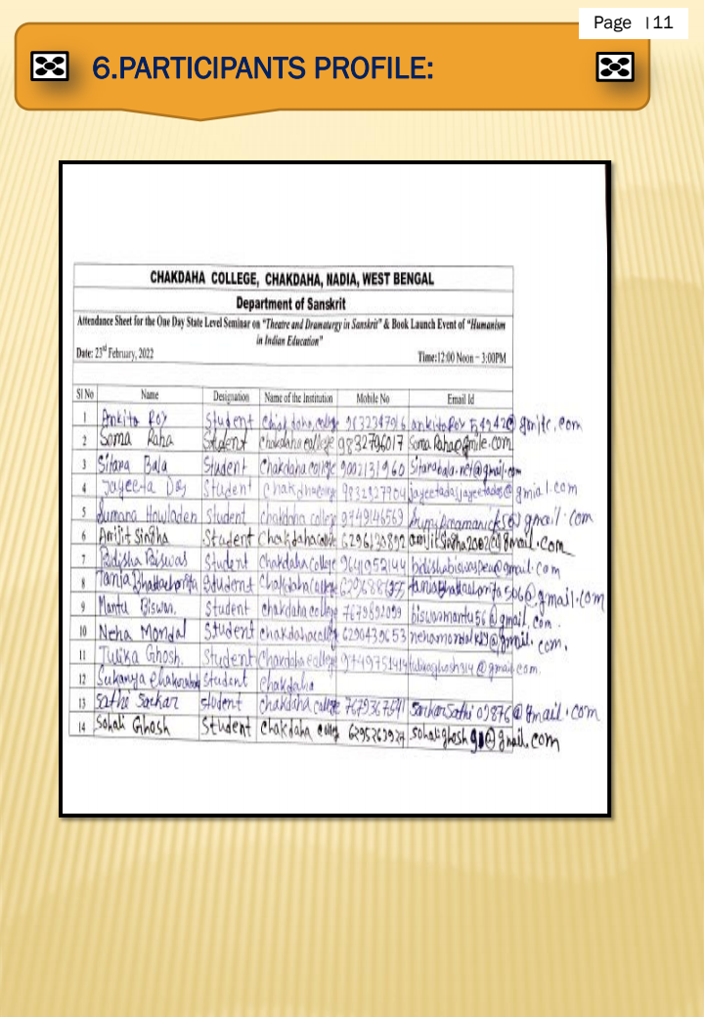Attendance:

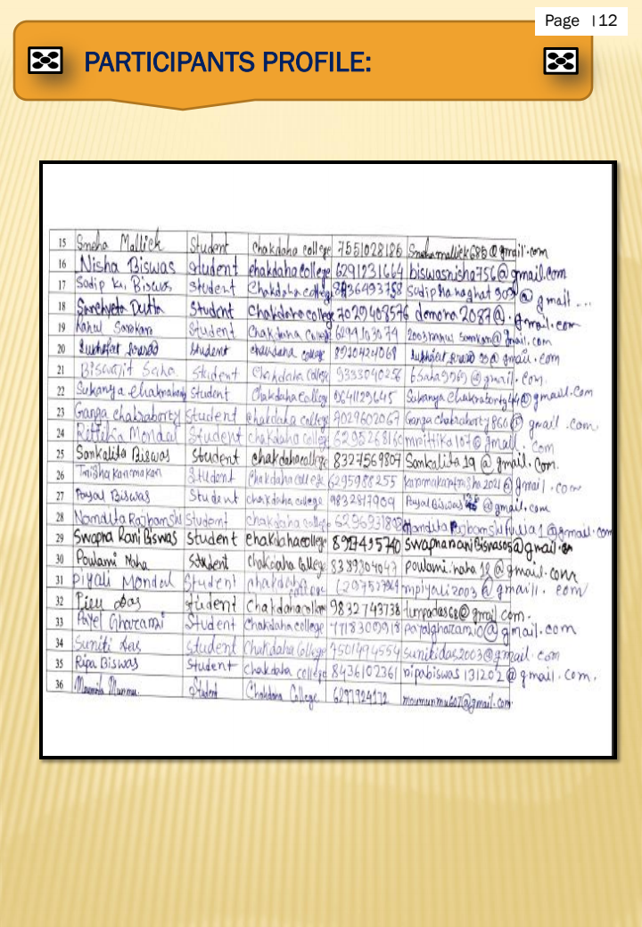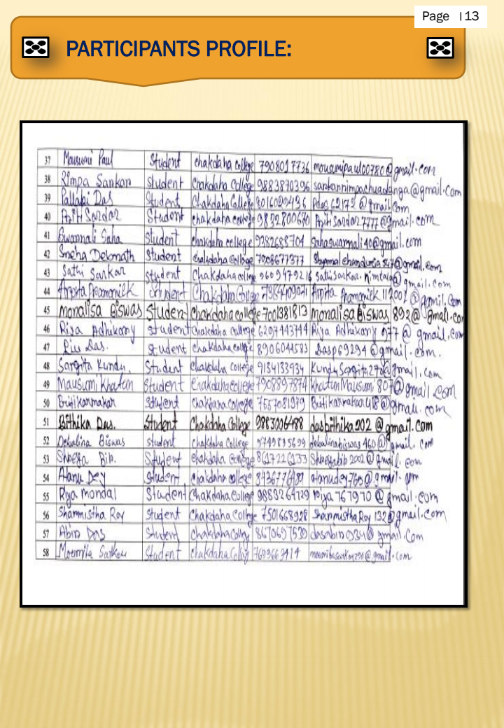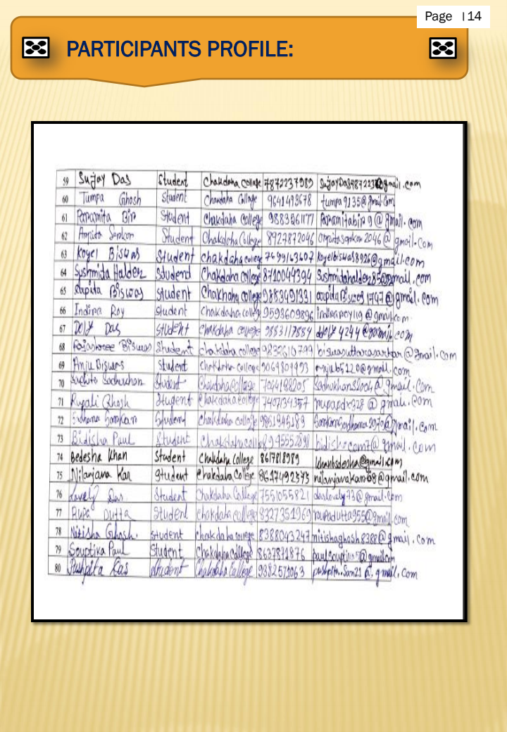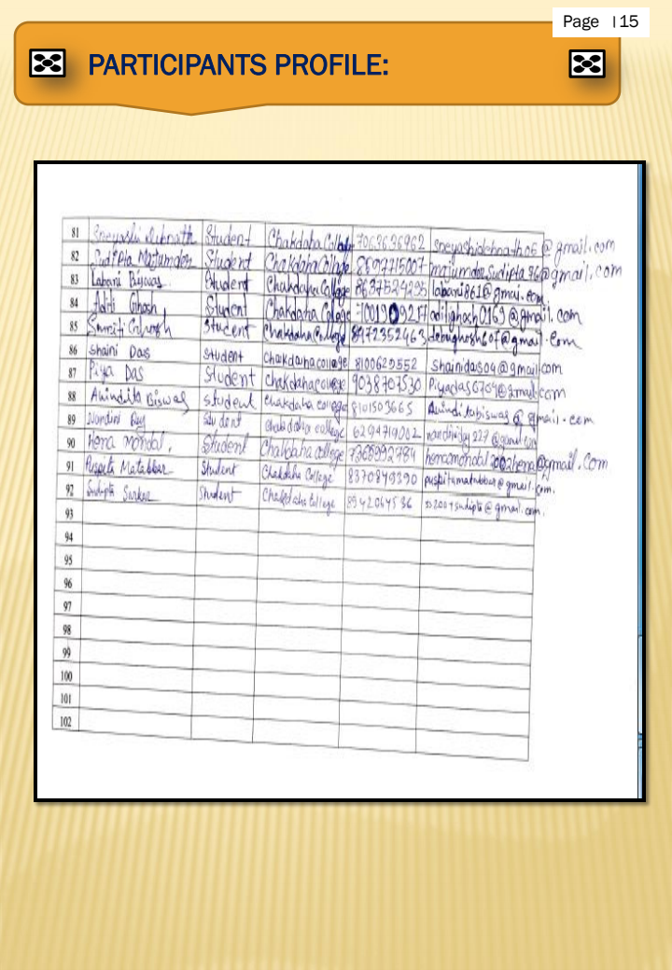

***Relevant Web Link:***

<https://www.facebook.com/photo/?fbid=459683845892250&set=pcb.459683945892240>